caffine.csv <https://www.kaggle.com/datasets/heitornunes/caffeine-content-of-drinks>

Coffee Chain.csv <https://data.world/adsafj/coffee-shop/workspace/file?filename=Coffee+Chain.csv>

Coffee_Survey.csv <https://data.world/junyu-wei/assignment-1-data-collection-and-curation/workspace/file?filename=Coffee_Survey.csv>

CoffeeConsumption.csv <https://www.kaggle.com/datasets/nurielreuven/coffee-consumption-by-country-2022>

<https://www.researchgate.net/publication/340325391_Motivations_Influencing_Caffeine_Consumption_Behaviors_among_College_Students_in_Korea_Associations_with_Sleep_Quality>

Cleaning the data :

From the above collected data I would like to analyze the datasets separately and combine the information

<https://www.cspinet.org/caffeine-chart>

**Your Favorite Cafe Drinks, Ranked from Least to Most Caffeinated**

https://www.tasteofhome.com/collection/caffeinated-drinks/

Uncover new information in the data that is not self-evident (i.e. do not just plot the data as it is; rather, slice and dice the data in different ways, create new variables, or join separate data frames to create new summary information).

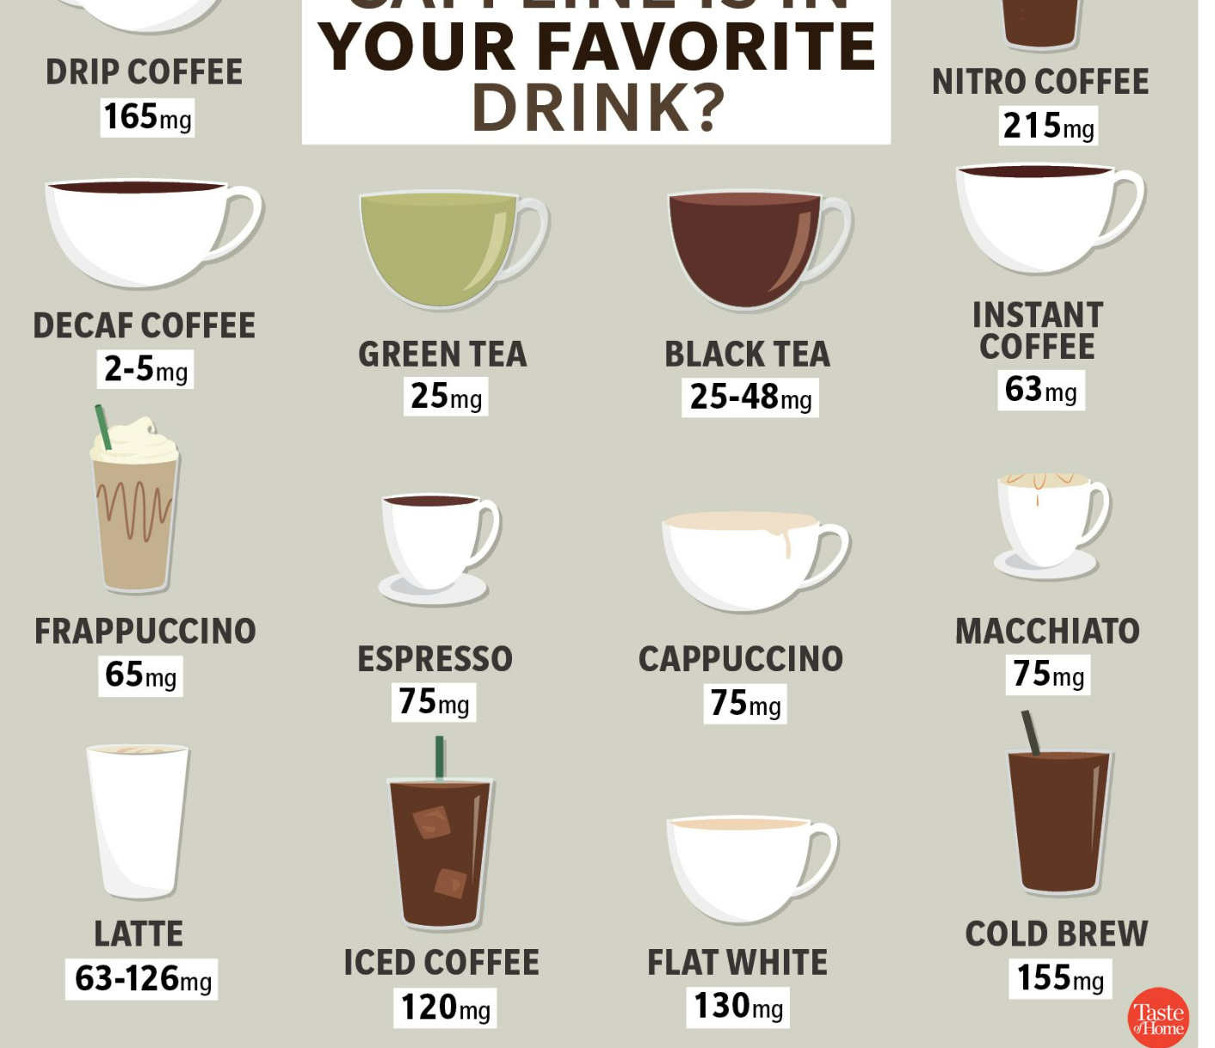

Herbal tea caffeinated values

<https://www.garfieldmedicalcenter.com/GMC-Blog/2016/October/Different-Types-of-Tea-and-Caffeine-Content.aspx#:~:text=Herbal%20Tea,sinensis%20plant%20as%20most%20teas>.

Amaretto caffeine values

<https://www.thespruceeats.com/amaretto-liqueur-history-1805685>

Colombian Coffee

<https://kitchenseer.com/colombian-coffee-more-caffeine/#:~:text=How%20Much%20Caffeine%20Does%20Colombian,around%20200%20milligrams%20of%20caffeine>.

Caffe Mocha

<https://www.caffeineinformer.com/caffeine-content/cafe-mocha>

Darjeeling

<https://www.bostonteacampaign.com/blogs/news/the-best-time-of-day-to-drink-darjeeling#:~:text=1)%20CAFFEINE%20LEVELS&text=Darjeeling%20can%20contain%20around%2050mg,green%20tea%20which%20contains%2040mg>.

Earl grey

<https://www.webmd.com/diet/earl-grey-tea-is-it-good-for-you#:~:text=Your%20cup%20of%20earl%20grey,Potassium>

|  |  |  |  |  |
| --- | --- | --- | --- | --- |
| Product | Caffeine content in mg / (237-300)ml | | |  |
| Decaf Irish Cream | #N/A | 2 |  |  |
| Decaf Espresso | #N/A | 25 |  |  |
| Chamomile | #N/A | 0 | herbal |  |
| Lemon | #N/A | 0 | herbal |  |
| Mint | #N/A | 0 | herbal |  |
| Amaretto | #N/A | 0 | alcoholic beverage | |
| Colombian | #N/A | 95 |  |  |
| Caffe Mocha | #N/A | 152 |  |  |
| Darjeeling | #N/A | 50 |  |  |
| Earl Grey | #N/A | 120 |  |  |
| Green Tea | #N/A | 45 |  |  |
| Regular Espresso | #N/A | 150 |  |  |
| Caffe Latte | #N/A | 126 |  |  |
|  |  |  |  |  |
|  |  |  |  |  |
|  |  |  | References |  |
|  |  |  |  |  |

Google, coffeeaffection,

<https://coffeeaffection.com/coffee-consumption-statistics/>

Google, realgoodcoffee,

<https://realgoodcoffeeco.com/blogs/realgoodblog/states-drink-most-coffee>

Google, Britannica,

<https://www.britannica.com/topic/coffee>

Google, Harvard T.H. chan,

<https://www.hsph.harvard.edu/nutritionsource/food-features/coffee/>